

Internet of things PROJECTS/INTERNSHIP

# College Name

* ****SRM Institute of Science and Technology.****

# Company Name

* ****Vyorius.****

# Domain

* ****Internet of things.****

### Project topics

### IoT based on smart Agriculture System.

### World map covid-19 dashboard.

### Obstacle Avoidance Robot using Ultrasonic Sensor.

### RGB Pattern.

### 4.RGB pattern

**Software's In detail**



* Tinkercad is a free online collection of software tools that help people all over the world think, create and make. We’re the ideal introduction to Autodesk, the leader in 3D design, engineering and entertainment software.

**Hardware In detail**

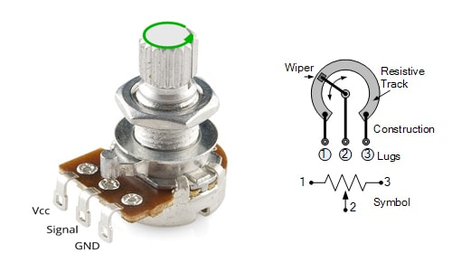

A potentiometer is a three-terminal resistor with a sliding or rotating contact that forms an adjustable voltage divider. Potentiometers are commonly used to control electrical devices such as volume controls on audio equipment.

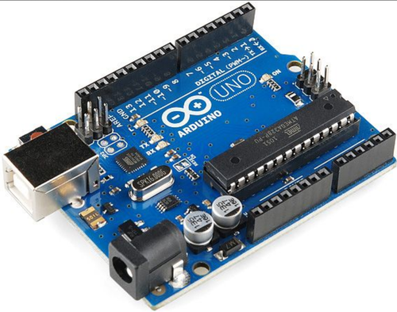

ATmega328P is a high performance yet low power consumption 8-bit AVR microcontroller that's able to achieve the most single clock cycle execution of 131 powerful instructions thanks to its advanced RISC architecture. It can commonly be found as a processor in Arduino boards such as Arduino Fio and Arduino Uno

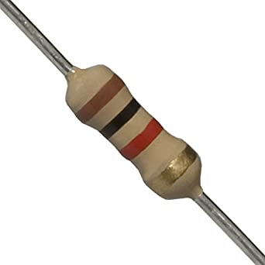

A resistor is a passive electrical component with the primary function to limit the flow of electric current.

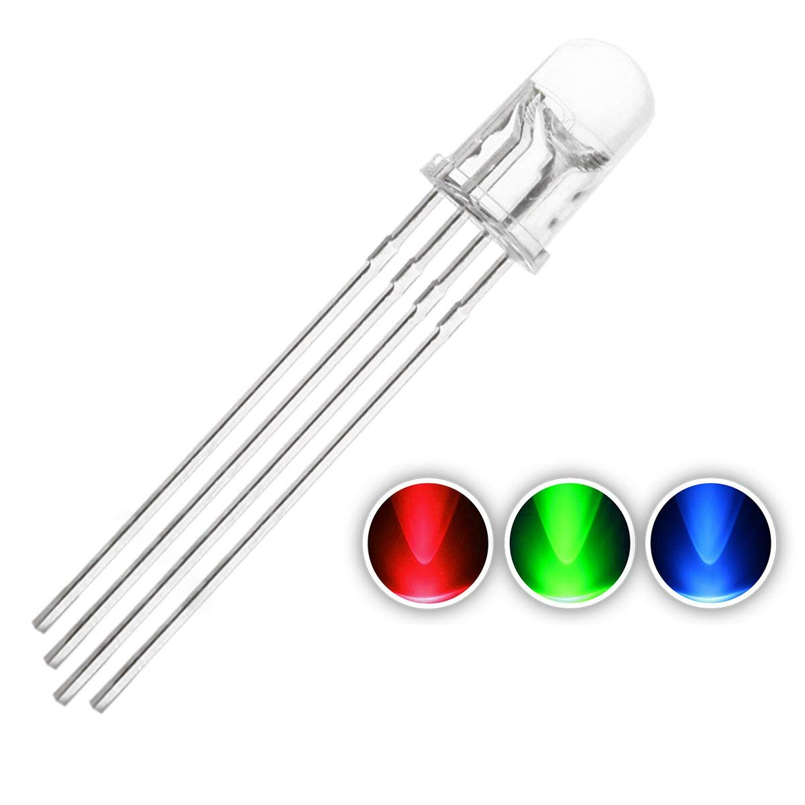

An RGB LED is basically an LED package that can produce almost any color. It can be used in different applications such as outdoor decoration lighting, stage lighting designs, home decoration lighting, LED matrix display, and more.

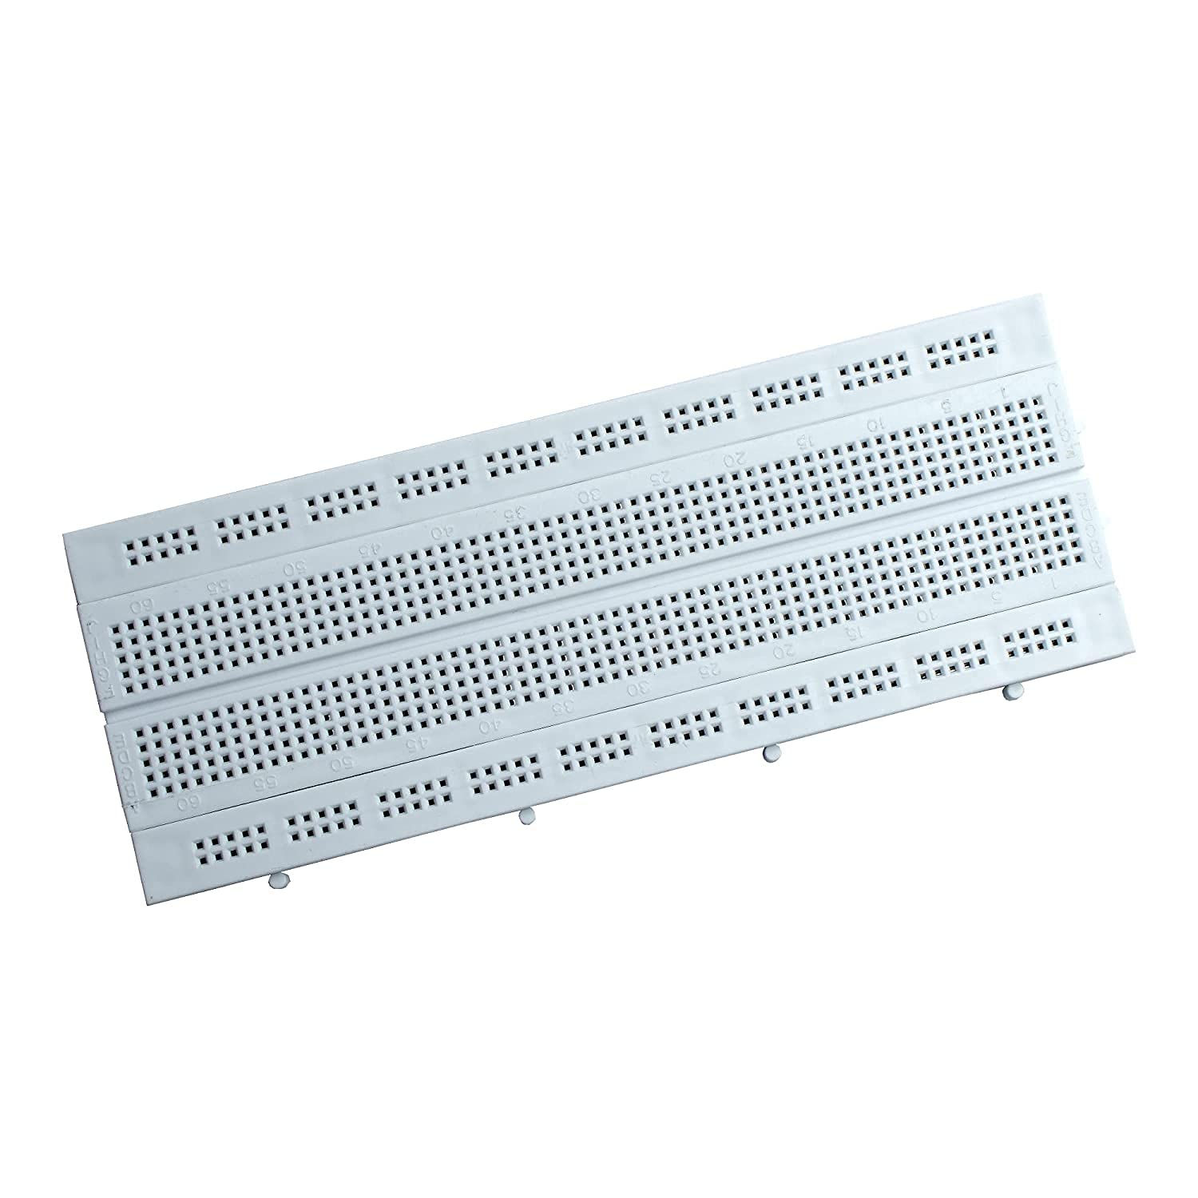

A breadboard is a rectangular plastic board with a bunch of tiny holes in it. These holes let you easily insert electronic components to prototype (meaning to build and test an early version of) an electronic circuit, like this one with a battery, switch, resistor, and an LED (light-emitting diode).

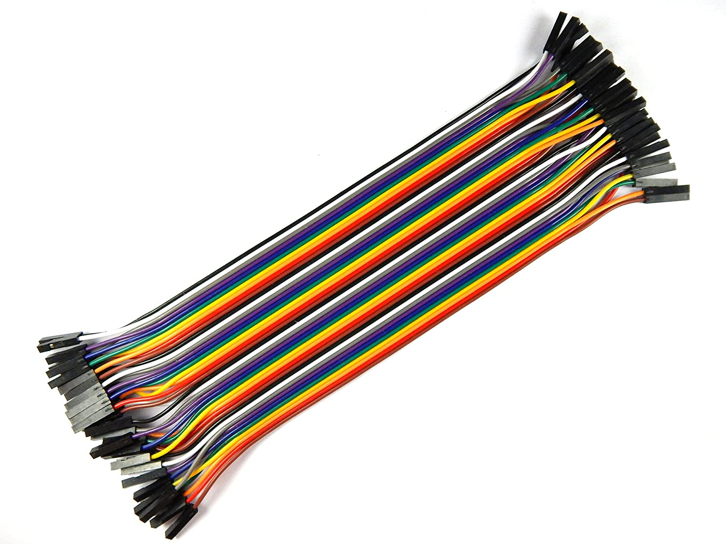

A jump wire (also known as jumper, jumper wire, jumper cable, DuPont wire or cable) is an electrical wire, or group of them in a cable, with a connector or pin at each end (or sometimes without them – simply "tinned"), which is normally used to interconnect the components of a breadboard or other prototype or test.

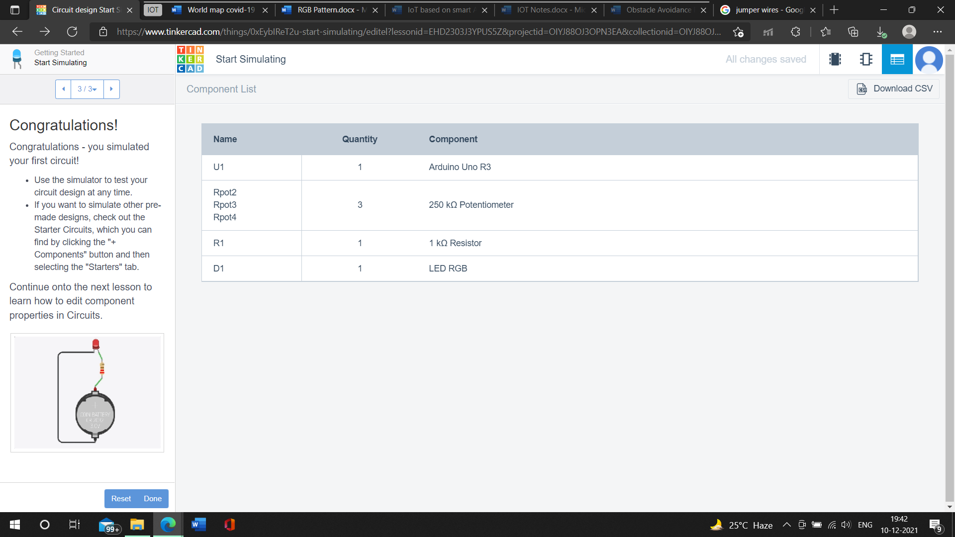

**SCHEMATIC VIEW**

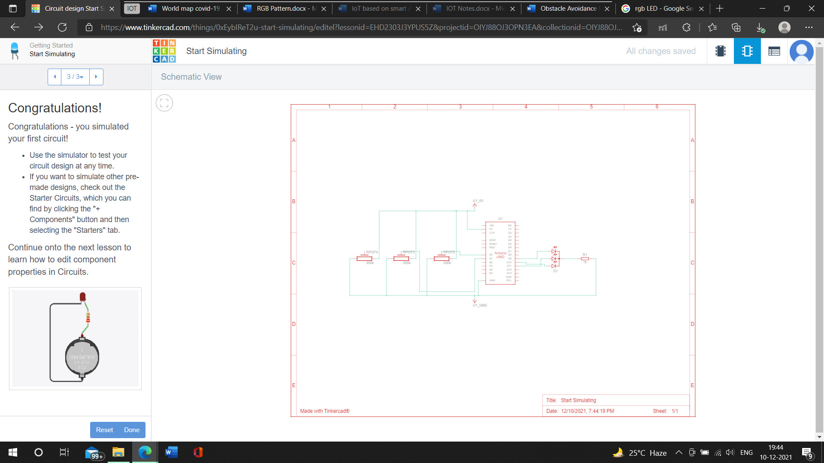**CIRCUIT VIEW**

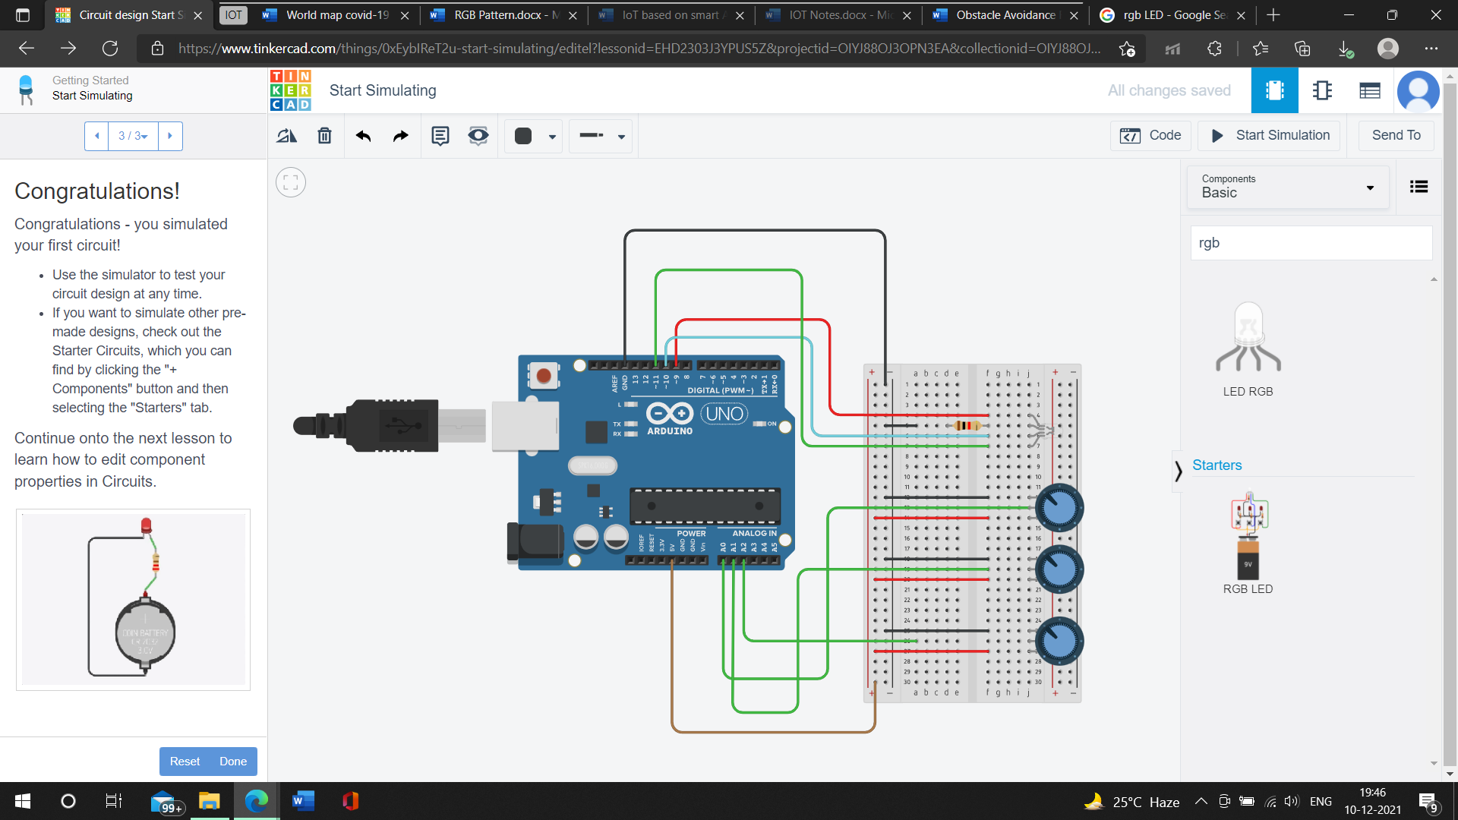

**CODE**

void setup(){

Serial.begin(9600);

pinMode(9, OUTPUT); //R

pinMode(10, OUTPUT); //B

pinMode(11, OUTPUT); //G

pinMode(A0, INPUT); //R

pinMode(A1, INPUT); //B

pinMode(A2, INPUT); //G

}

void loop(){

int r_value= analogRead(A0); //R

int b_value= analogRead(A1); //B

int g_value= analogRead(A2); //G

int r_m_value= map(r_m_value, 0, 1023, 0, 255); //R

int b_m_value= map(b_m_value, 0, 1023, 0, 255); //B

int g_m_value= map(g_m_value, 0, 1023, 0, 255); //G

analogWrite(9, r_m_value); //R

analogWrite(10, b_m_value); //B

analogWrite(11, g_m_value); //G

Serial.print(r_m_value);

Serial.print(" ");

Serial.print(b_m_value);

Serial.print(" ");

Serial.println(g_m_value);

delay(500);

}

